**Assignment 2:**

Design a database schema for a library system, including tables, fields, and constraints like NOT NULL, UNIQUE, and CHECK. Include primary and foreign keys to establish relationships between tables.

Tables used to design library system.

* Library
* Book
* Author
* Member
* Book Author

Constraints:

* **Primary Keys**: Unique identification for each record in the table.
* **Foreign Keys**: Establish relationships between tables.
* **NOT NULL**: Field must have a value.
* **UNIQUE**: Field must have unique values.
* **CHECK**: Ensuring that a field's value meets a specific condition.

**Tables and Relations:**

**Library Table:**

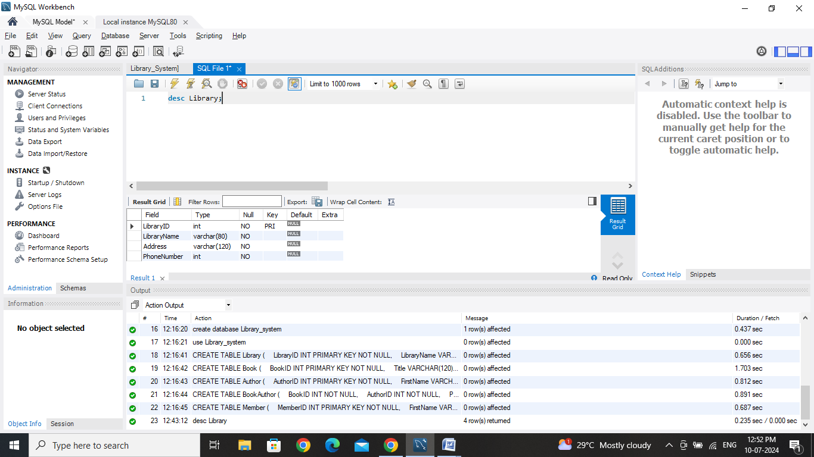

Fields in Library Table:

* LibraryID : Primary Key, int, NOT NULL
* LibraryName : varchar(80), NOT NULL
* Address : varchar(120), NOT NULL
* PhoneNumber: int, Checks Should be in PhoneNumber 9 AND PhoneNumber <= 13

**Book Table:**

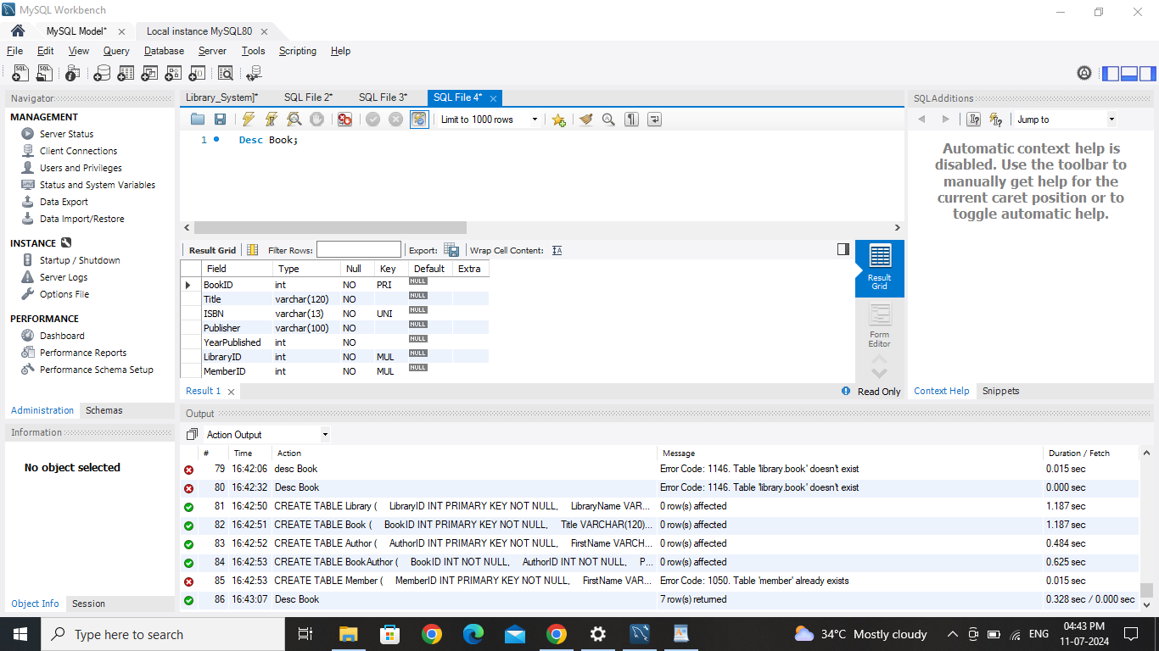

Fields in Book Table:

* BookID : Primary Key, Int, NOT NULL
* Title : varchar(120), NOT NULL
* ISBN : varchar(13), UNIQUE, NOT NULL
* Publisher : varchar(100), not null
* YearPublished : Int
* LibraryID : Foreign Key, INT, NOT NULL
* MemberID : Foreign Key, INT, NOT NULL

**Author Table:**

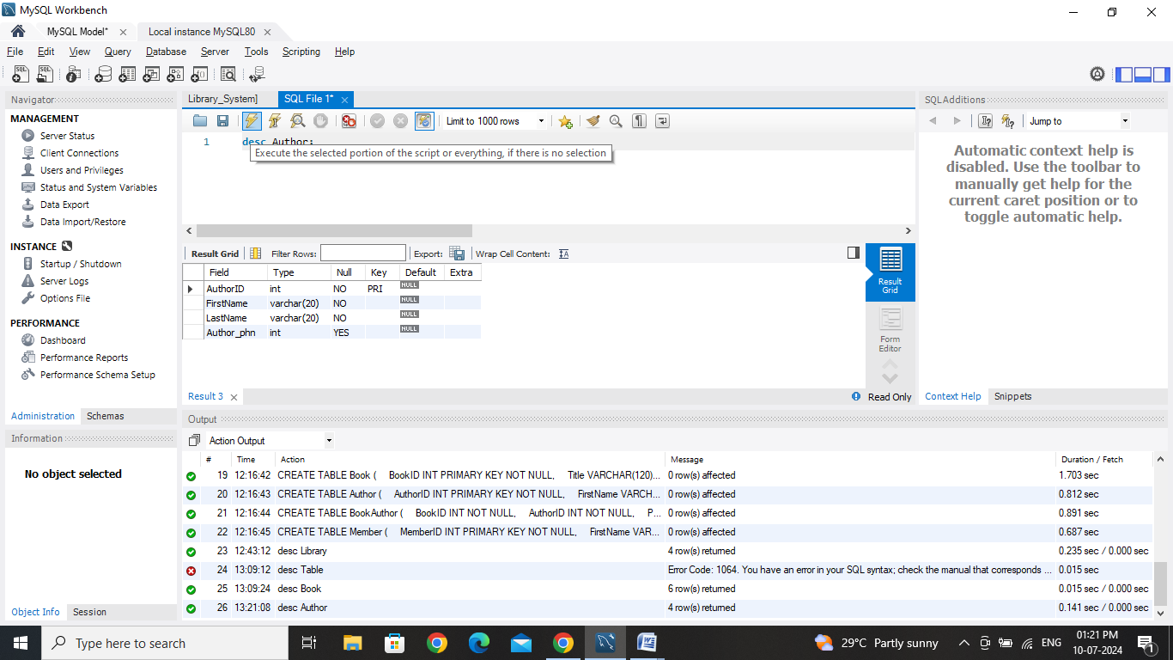

Fields in Book Table:

* AuthorID : Primary Key, Int, NOT NULL
* FirstName : varchar(20), NOT NULL
* LastName : varchar(20), NOT NULL

**Member Table :**

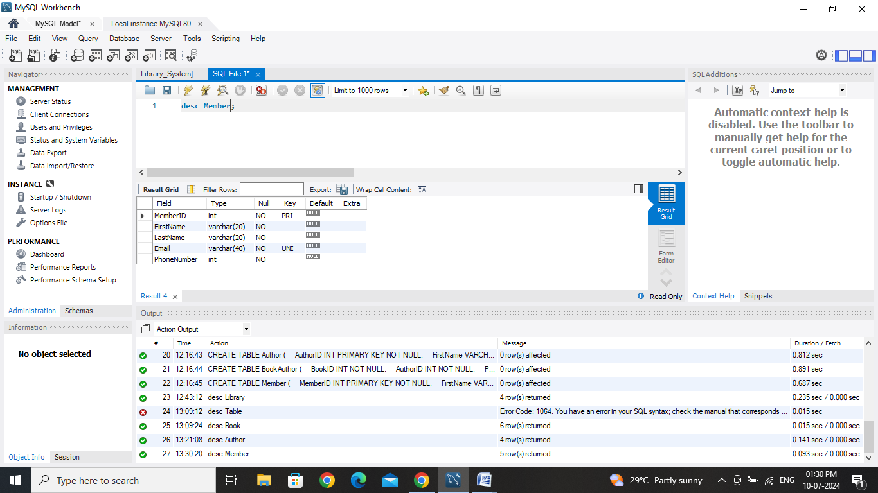

Fields in Member Table:

* MemberID (Primary Key, Int, NOT NULL)
* FirstName (varchar(20), NOT NULL)
* LastName (varchar(20), NOT NULL)
* Email (VARCHAR(40), UNIQUE, NOT NULL)
* PhoneNumber: Int, Checks Should be in PhoneNumber 9 AND PhoneNumber <= 13

**BookAuthor Table :**

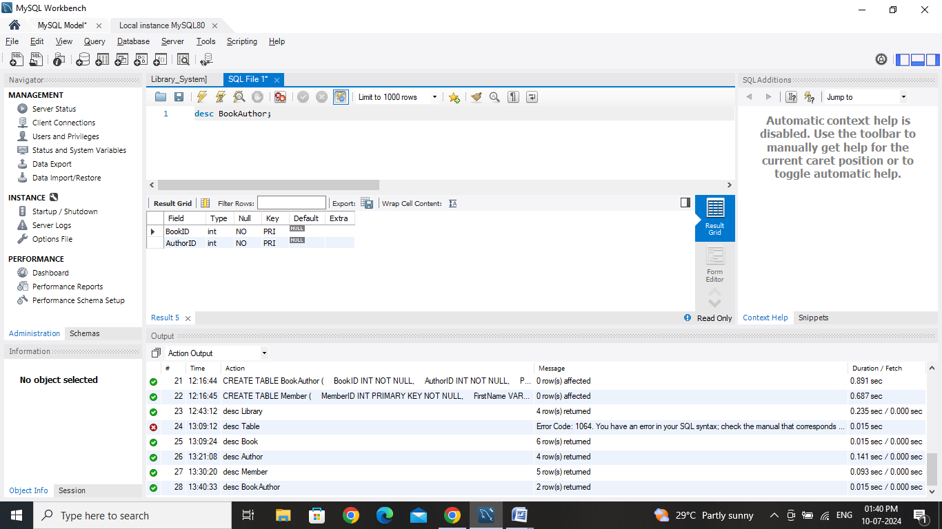

Fields in BookAuthor Table:

* BookID : Foreign Key, Int, NOT NULL
* AuthorID : Foreign Key, Int, NOT NULL
* **PRIMARY KEY** BookID, AuthorID

**Database Schema**

1. **Library** (LibraryID, Name, Address, PhoneNumber)
   * One-to-Many relationship with **Book**
2. **Book** (ISBN, Title, PublicationYear, LibraryID)
   * Many-to-One relationship with **Library**
   * Many-to-Many relationship with **Author** through **BookAuthor**
3. **Author** (AuthorID, FirstName, LastName, DateOfBirth)
   * Many-to-Many relationship with **Book** through **BookAuthor**
4. **Member** (MemberID, FirstName, LastName, DateOfBirth, Email, PhoneNumber, Address, MembershipDate)
   * One to many with **Book**
5. **BookAuthor** (BookAuthorID, ISBN, AuthorID)
   * Many-to-One relationship with **Book**
   * Many-to-One relationship with **Author**

**Visual Representation :**

